

缝纫机系列 **使用说明书**

**Sewing machine series**



**WS-8600**

自动袖衩缝纫机

Automatic sleeve placket attaching machine

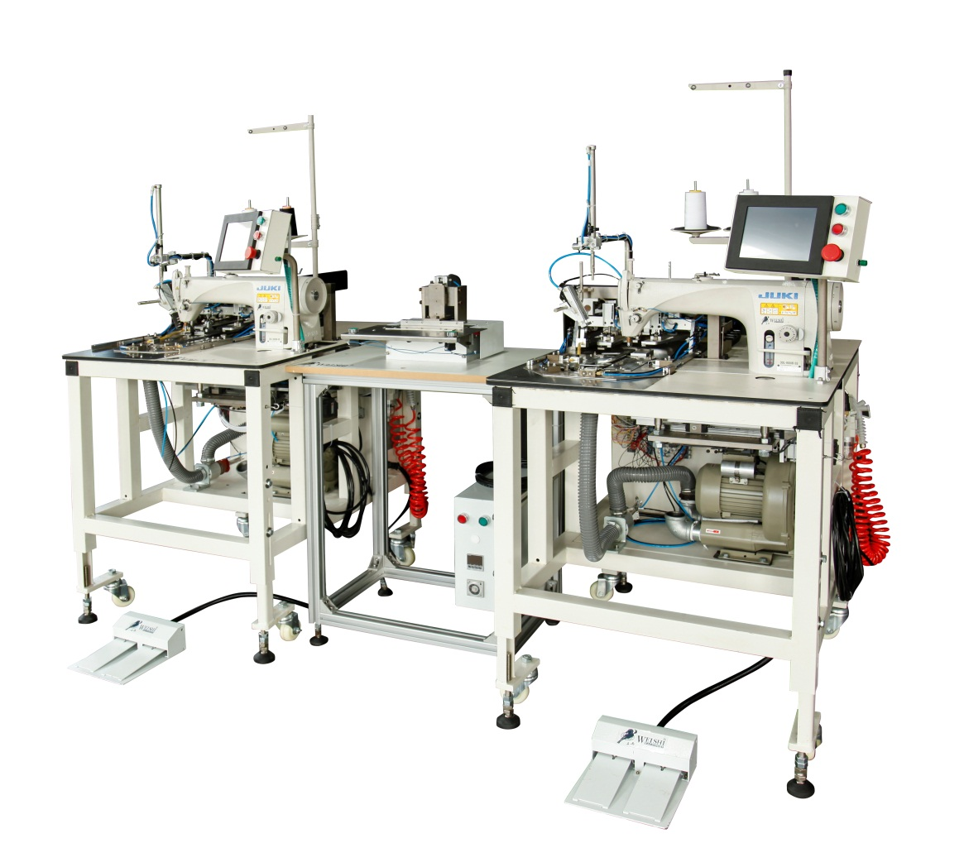

**上海威士机械有限公司**

**HANGHAI WEISHI MACHINERY CO.,LTD.**

**Preface**

**This manual is written for technical service staffs and operating personnel.**

**In the Operation Manual for sewing machine preservers in the garment factory and the sewing operators, we have made a thorough explanation on how to use this sewing machine. So in this Service Manual, we will make some explanations on particular and relevant functions, on the adjustment methods for compiling, on the phenomenon resulted from changes in value and other various functions.**

**In addition to this manual, please refer to other Operation Manuals and parts list when preserving and repairing this machine.**

**For a safe adjustment operation.**

**Adjustments: Parts' replacement, removal, repair, assemble and other operations.**

Before adjusting the sewing machine, the automatic machine and the appendant devices (hereinafter called the machine), the operator should read the machine’s “Important Safety Instructions" carefully and understand it fully.

The "Important Safety Instructions" in this Service Manual explains some items which are not included in the machinery specification you bought.

Besides, in order to make you fully understand this Service Manual and the warning signs stickup in the machine body, the warning signs are used separately according to the following descriptions.

You should fully understand and consciously comply with its contents.

**(1) Descriptions about the dangerous level**

|  |  |
| --- | --- |
| **叹号Danger** | When operating and maintaining the machine, the dangerous parts which could cause death or serious injury by the third person's misoperation and the privies couldn't avoid. |
| **叹号Warning** | The potential parts which could cause death or serious injury by the third person's misoperation and the privies couldn't avoid when operating and maintaining the machine. |
| **叹号Caution** | The parts which could cause moderate or minor injury by the third person's misoperation and the privies couldn't avoid when operating and maintaining the machine. |

**(2) Descriptions about the indications of the warning patterns**

|  |  |  |  |  |  |
| --- | --- | --- | --- | --- | --- |
| **Warning patterns** |  | **Moving Parts: be cautious of the industrial accident.** |  |  | **Belt Drive: be cautious of the industrial accident.** |
|  | **High Voltage Parts: be cautious of electric shock.** | **Indication Sign** |  | **Indicate the correct direction of rotation** |
|  | **High Temperature Parts: be cautious of scalding accident.** |  | **Indicate the earth wire that should be earthed.** |

**Important Safety Instructions**

Accident: Refers to the physical and property damage.

Cut off the power: Refers to turn off the power switch and pull out the power plug from the socket.

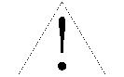 Danger

To prevent the electric shock, when it is necessary to open the electrical cabinet,

please cut off the power first and then open the electrical cabinet after at least

5 minutes.

* Caution

Basic precautions

1. To prevent human injury, please read and understand this Service Manual before operating.

Besides, in order to use this Service Manual easily at any time, please keep it properly.

1. To prevent accidents caused by accidental start, please cut off the power before making any adjustment. When it has to operate with the power on, please do not step on the pedal or press the start button. When leaving the machine, it is necessary to cut off the power.
2. To prevent human injury, please verify whether the connecting terminal, cable and other thins are damaged, loosen and so on after making adjustments.

**Education and Training**

1. To prevent human injury when adjusting the operation, the person who is responsible should be taught about the latest information and safety knowledge, and be trained to operate according to this Service Manual and the Operation Manual.

**Mechanical adjustment**

1. To prevent the accidents caused by misadjustments， the adjustment should be made according to this Service Manual and the Operation Manual by the maintenance technician who is familiar with mechanistic relations and has been trained about the safety knowledge.
2. Please use the genuine components made by our company when replacing components.

Our company shall not bear the responsibility for the incidents caused by inappropriate adjustment and for the using of the components which are not made by our company.

If the adjustment can't be made within the range of indication, you should terminate the repairing work immediately and authorize the technician in our company or in the agency shop to solve.

1. To prevent human injury, please verify whether the screws and nuts are loose after making adjustment.
2. To prevent human injury, when unexpected things happen during adjustment or machine still can't work normally after adjustment, please stop operating immediately.
3. To prevent human injury, when adjusting, the safety devices removed or damaged should be installed at its original place and verify whether they are normal and valid.
4. To prevent human injury, the warning signs stickup in the machine should be able to see clearly at any time. When they are desquamated or contaminated, you should replace a new one immediately.

**Electrical adjustment**

1. To prevent accidents and electric shock, please authorize the specified person with electrical knowledge or the technician in our company or in the agency shop to make the adjustment.
2. To prevent human injury, if the fuse blows out, please cut off the power, find out the cause, eliminate the trouble, and then replace a new fuse with the same capacity (specification).
3. To prevent human injury, please verify whether the connecting terminal, cable and other things are damaged, loose and shed after making adjustments.

**Air-pressure equipment adjustment**

1. To prevent accidents caused by accidental start, when using air cylinder and other air-pressure components to make adjustment, please cut off the air supply and drain the internal compressed air first.
2. To prevent accidents caused by faulty action, please verify whether there is water in cylinder and air tube.

**Mechanical adjustment in clutch motor**

1. After cutting off the power, the clutch motor will continue to spin because of its inertia. To prevent human injury, please start to adjust after verifying the motor has stopped.

**Mechanical application and transformation**

1. To prevent human injury, do not make any adjustment or transformation which is not complied with the specifications of the machine. Our company shall not bear any responsibility for the accidents caused by such adjustment or transformation.
2. To prevent human injury, do not operate exceeding the machine's using range or the usage specified in this Service Manual and the Operation Manual. Our company shall not bear any responsibility for the accident caused by such operation.

Machinery Part

**Precautions in various stages**

* **Caution**

**Move**

1. To prevent human injury, please use two or more than two persons to lift this machine and use a moped to move it.
2. To prevent human injury, please adopt sufficient safety precautions to prevent accidental drop and turnover when lifting or moving.
3. We have made a thorough explanation about the installation in the Operation Manual, please read carefully and fully understand before operating.

**Component Replacement**

1. To prevent human injury, please replace the component under the direction of this Service Manual and the Operation Manual.
2. To prevent occupational injury and human injury, please operate after cutting off the power.
3. To prevent human injury, please operate after the machine has been installed steadily. Meanwhile, it is necessary to choose appropriate tools.
4. To prevent human injury, please verify whether the screws and nuts are loose, whether they have unexpected contact with other components after finishing operation.
5. Please use the genuine components made by our company to replace.

Our company shall not bear any responsibility for the accidents caused by the using of the components which are not by our company.

If you couldn't replace the components normally under the direction, please stop repairing and contact with the technicians in our company or the agency shop.

**Adjustment**

1. To prevent human injury, please make adjustments within the range indicated in this Service Manual and the Operation Manual.
2. To prevent human injury, please operate after the machine has been installed steadily. Meanwhile, it is necessary to choose appropriate tools.
3. To prevent human injury, please verify whether the screws and the nuts are loose, whether they have unexpected contact with other components after finish operating.
4. To prevent human injury, when it has to operate with the power on, please be careful enough and do not press the button accidentally.
5. To prevent human injury and being involved in the machine, please be careful enough and do not let your hair or clothes touch the transmission part when operating sewing test.

**Disassemble, Assemble**

1. To prevent human injury, please make adjustments within the range indicated in this Service Manual and the Operation Manual.

2. To prevent human injury, please operate after the machine has been installed steadily.

3. To prevent human injury, please verify whether there is unexpected contact between components after finishing assemble.

4. To prevent human injury, when solidifying the screw and the nut, if there is specified torsional moment, please solidify in coincidence with the requirement; if there is no such requirement, please solidify in an appropriate torsional moment.

5. To prevent human injury, please verify whether the direction of rotation is correct during trial running.

6. To prevent human injury during trial running, please be careful enough and do not let your hair or clothes touch the transmission part.

Electricity Part

**Precautions in various stages**

* **Caution**

**Move**

1. To prevent human injury, please use two or more than two persons to lift this machine and use a moped to move it.

2. To prevent human injury, please adopt sufficient safety precautions to prevent accidental drop and turnover when lifting or moving.

3. We have made a thorough explanation about the installation in the Operation Manual, please read carefully and understand fully before operating.

**Component Replacement**

1. To prevent accidents and electric shock, please authorize the technicians with electrical knowledge to operate.

2. To prevent the accidents and electric shock, when it is necessary to open the electrical cabinet, please cut off the power first and then open the electrical cabinet after at least 5 minutes. Do not operate when your hands are wet.

3. To prevent human injury, please replace the components under the directions in this Service Manual and the Operation Manual.

4. To prevent human injury, please operate after the machine has been installed steadily. Meanwhile, it is necessary to choose appropriate tools.

5. To prevent human injury, please verify whether this component has unexpected contact with

other components after replacing and verify whether the connecting terminal and the plug

are poor contact, whether the screws and nuts are loose.

6. To prevent human injury, please verify whether the connecting terminal, cable head are damaged, shed or loose after operating.

According to the request of security, there are some floating polyvinyl chloride tube, insulating tape and other insulating materials, and the internal wiring adopt the circuitous way in order to keep away from the high-tension line. And all of them should be repristinated after operating.

7. Please use the genuine components made by our company to replace.

Our company shall not bear any responsibility for the accidents caused by the using of the components which are not made by our company.

If you couldn't replace the components normally under the direction, please stop repairing and contact with the technicians in our company or in the agency shop.

8. To prevent human injury, if the fuse blows out, please cut off the power, find out the

cause, eliminate the trouble, and then replace a new fuse with the same

capacity (specification).

**Adjustment**

1. To prevent accidents and electric shock, please authorize the technicians with electrical knowledge to operate.

2. To prevent the accidents and electric shock, when it is necessary to open the electrical cabinet, please cut off the power first and then open the electrical cabinet after at least 5 minutes. Do not operate when your hands are wet.

3. To prevent human injury, please make adjustments on the adjustable components

(variable inductance, potentiometer, variable capacity) according to the indications in this

Service Manual and the Operation Manual only

4. To prevent human injury, please operate after the machine has been installed steadily.

Meanwhile, it is necessary to choose appropriate tools.

5. To prevent human injury, please verify whether the screws and the nuts are loose, whether they have unexpected contact with other components.

6. To prevent human injury, please verify whether the connecting terminal, cable head are damaged, shed or loose after operating.

7. To prevent human from injury and being involved in the machine, please be careful enough and do not let your hair or clothes touch the transmission part when operating sewing test.

**Disassemble, Assemble**

1. To prevent human injury, please make adjustments within the range indicated in this Service Manual and the Operation Manual.

2. To prevent the accidents and electric shock, when it is necessary to open the electrical cabinet, please cut off the power first and then open the electrical cabinet after at least 5 minutes. Do not operate when your hands are wet.

3. To prevent human injury, please replace the components under the directions in this Service Manual and the Operation Manual.

4. To prevent human from injury, please operate after the machine has been installed steadily.

Meanwhile, it is necessary to choose appropriate tools.

5. To prevent human injury, when solidifying the screw and the nut, if there is specified torsional moment, please solidify in coincidence with the requirement; if there is no such requirement, please solidify in an appropriate torsional moment.

6. To prevent human injury, please verify whether the screws and nuts are loose, whether they have unexpected contact with other components.

7. To prevent human injury, please verify whether the connecting terminal, cable head are damaged, shed or loose after operating.

According to the request of security, there are some floating polyvinyl chloride tube, insulating tape and other insulating materials, and the internal wiring adopt the circuitous way in order to keep away from the high-tension line. And all of them should be repristinated after operating.

8. To prevent human injury, please verify whether the direction of rotation is correct during trial running.

9. To prevent human from injury during trial running, please be careful enough and do not let your hair or clothes touch the transmission part.

**Important Safety Instructions about WS-8600**

|  |  |
| --- | --- |
| **Danger** | 1. To prevent electric shock, during the power supply importing period, do not touch the components in the electrical cabinet when the motor electrical cabinet is open.  2. After changing pattern, please verify the needle point. Once the pattern exceeds the presser foot, the needle would run into the presser foot and snap. |
| **Caution** | 1. When power is on, but no display on the operation screen, please cut off the power and verify the supply voltage and the power source specification.  2. To prevent the accident caused by the accidental start, before pressing the start button please verify there is no barriers underneath when coiling.  3. When the power button is off, the setout button is on, and the presser foot button is on, do not put your fingers beneath the presser foot, because the presser foot will automatically fall down. |

**Safety Device**

The machineries and safety devices recorded here are made under the domestic specifications; the devices may be different according to different sale places

**关于安全装置**

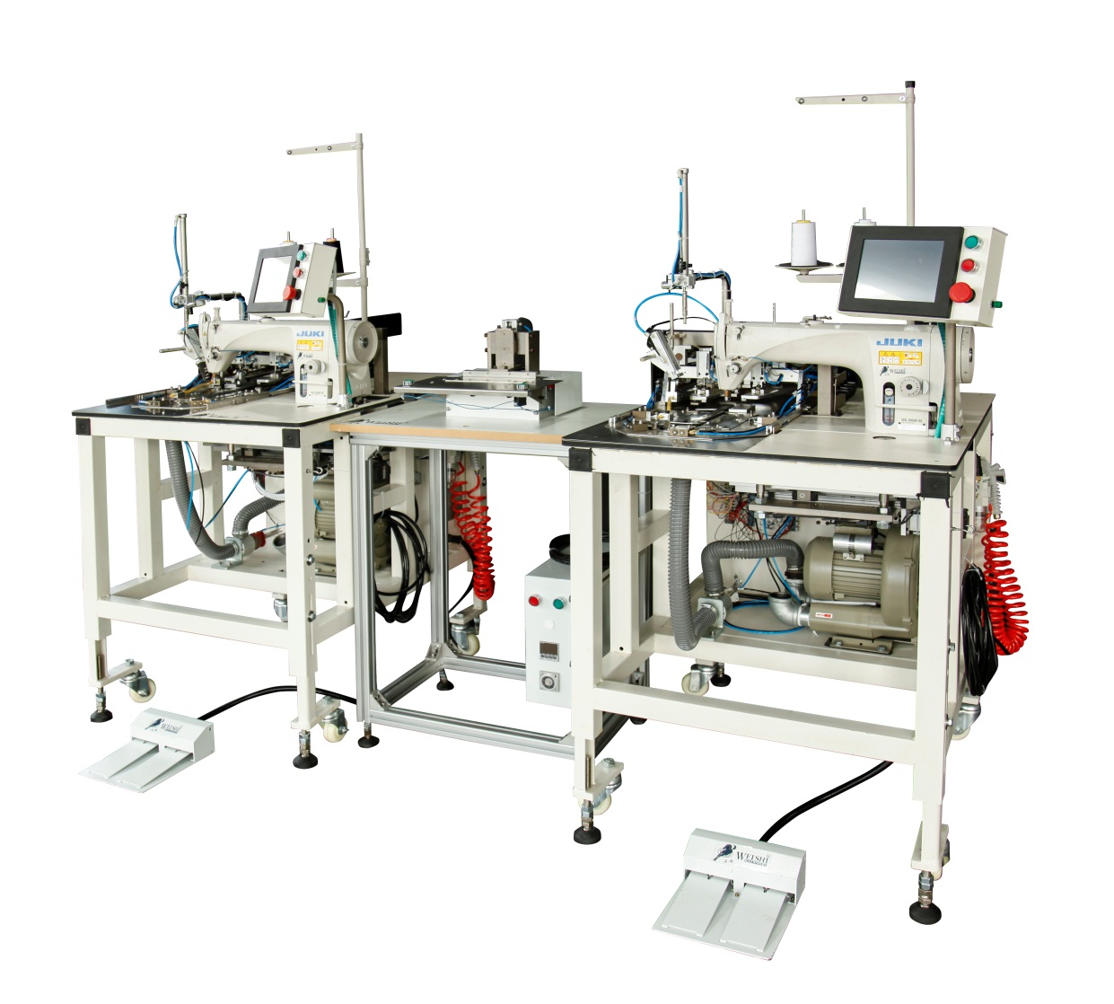****

Please be kindly noted these Safety warnings all time

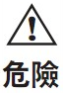

**DANGER The book, in some places have been omitted the eye shield, therefore pre-informed you that, in actual use, you should never remove the safety device!**



**Contents**

**ONE .Basic Parameter 1**

**TWO. Names of each part 2**

**1、Name of main machine 2**

**2、operation panel 3**

**3、menu of main interface 3**

（1）sub-menu of interface 3

（2）parameter and IO test 6

**4、 folding edge parameter setting 6**

**5、 Patten selection screen 8**

**6、Calibration interface 9**

**7、Gallery interface 11**

**8、Manual testing interface 13**

（1）motor manual testing 13

（2）IO testing 14

**9、auxiliary function interface 15**

**THREE. OPERATON 16**

**1、Operation 16**

**2、function systems and setting 17**

（1）pattern creation and edit 17

（2）pattern calibration procedure 18

（3）pattern change procedure 19

**FOUR. List of Failure Information 20**

**Five. Electrical Schematic Diagram 23**

**一、规格参数**

|  |  |  |
| --- | --- | --- |
| NO. | ITEM | Basic parameters |
| 1 | Maximum sewing speed (needle/min) | 3000 |
| 2 | Stitch length/mm / mm | 1-3 |
| 3 | needle number | DB×11#11-14# |
| 4 | Cloth feeding mode： | INTERMITTENT |
| 5 | Sewing scope/mm | 30W×200L |
| 6 | Rated voltage/V | 220 |
| 7 | Operating air pressure/Mpa | 0.5 |
| 8 | Air consumption/L/min | 200 |
| 9 | Dimension mm | 1120L×760W×1600H |
| 10 | Weight | 350Kg |

**specificaton**

**※ Maximum sewing speed can be used according to the drop speed of the sewing condition。**

**NAME OF EACH PARTS**

**二、各部位的名称**

1. **主机的名称**

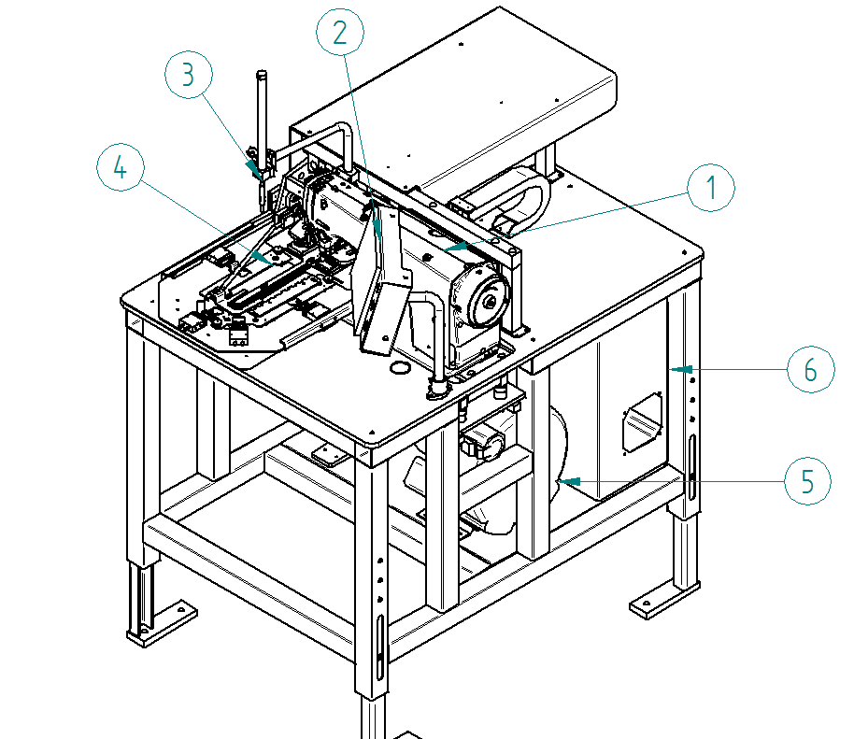

1、SEWING HEAD 2、OPERATION PANEL

3、 LOW RAISING SYSTEMS 4、EDGE FOLDING SYSTEMS

5、 FAN MOTOR 6、ELECTRIC BOX



**2. 操作控制面板的名称和说明**

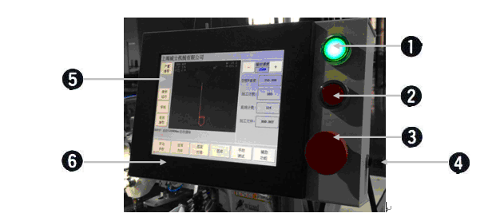

|  |  |  |
| --- | --- | --- |
|  | button | description |
|  | Power ON | Main supply of the machine is on after this button being pressed. |
|  | Power OFF | Main supply of the machine is off after this button being pressed. |
|  | EMERGENCY | The system will stop after emergency button being pressed, thereafter, press button  or system restoration when emergency button is canceled.。 |
|  | Reset Button | Servo returns to zero point and the machine enters into work state after this button being pressed. |
|  | Human-machine Interface | Set sewing parameter and select machining graphics on human-machine interface. |
|  | TOUCH SCREEN | 8” TOUCH SCREEN。 |

**3. 主界面菜单**



When the boot initialization is finished, the system will automatically enter the main screen, Please do not operate the machine during this time, because the system is not ready state.

Plrese RESET the machine after e initialization procedure

（1）SUB-MENU OF INTERFACE：

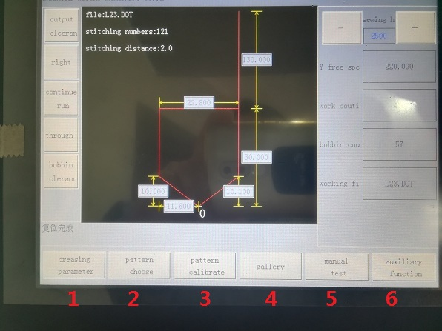

|  |  |  |
| --- | --- | --- |
|  | Button | description |
|  | Creasing parameter | To set the creasing parameter，production parameter and choose function |
|  | Pattern choose | To choose the patter file and set the needle distance。(with a security level 1 of the picture) |
|  | Pattern calibrate | To calibrate the pattern and set the location of starting ，material picking ，ending sewing and etc. (with a security level 2 of the picture). Non-professionals please do not to get into and modify parameters。 |
|  | Gallery | To create new pattern |
|  | Manual test | To maual test the movement and IO signal。(with a security level 1 of the picture) |
|  | Auxiliary function | To set some other parameter, file manager and systems information. |

（2）parameter and operation：

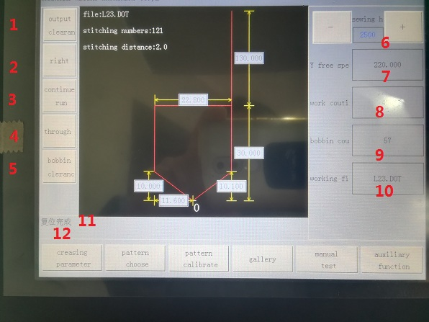

|  |  |  |
| --- | --- | --- |
|  | button | description |
|  | Output clearance | Clear off the production quantity |
|  | Right/left placket | Right/left placket manual switch |
|  | Step/continuous run | Before stitching, choose the folding edge mode  （1）continuous：continuously fold edge；  （2）step: run step after step by pedal start |
|  | Thread through | Press it to lay down the upper and lower press plate , enable easy threading |
|  | Bobbin clerace | Clear off the bobbin capacity。 |
|  | Sewing speed | temporary Change the sewing speed“+/-”  It will be resumed to previous after screen switch or power restart |
|  | Y free speed | Y axis freely movement speed |
|  | Work counting | Production counting number |
|  | Bobbin counting | Bobbin counting number |
|  | Working file | The file name of processing currently |
|  | Run information | Currently run information |
|  | Alarm information | Current alarm information |

**4. 折边参数设置界面**

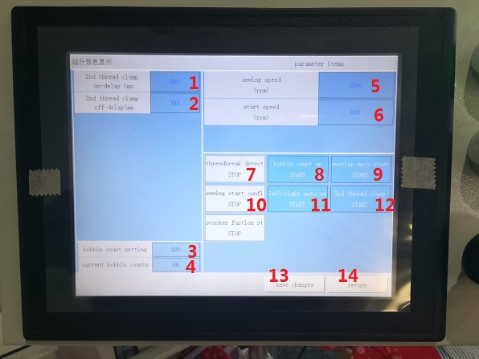

|  |  |  |
| --- | --- | --- |
|  | button | description |
|  | 2nd thread clanp on-delay(ms) | Time to 2nd thread clamp open(ms)。 |
|  | 2nd thread clanp off-delay(ms) | Time to 2nd thread clamp close(ms)。 |
|  | Bobbin count setting | Set the bobbin count。press“bobbin clearance”to clear current bobbin number |
|  | Current bobbin counting | Set the current bobbin counting |
|  | sewing speed（rpm） | Set the sewing speed when power on |
|  | Start speed（rpm） | Sewing speed in the begining |
|  | Thread break detector | Switch on/off the thread break detector |
|  | Bobbin counting function | Switch on/off the bobbin counting function。 |
|  | Vacuum motor | Switch on/off the vacuum motor |
|  | Sewing start confirmation | after folding the edge , Need Confirmation to stitch |
|  | Left/right placket automatic switch | Left/right placket automatic switch |
|  | 2nd thread clamp function | Switch on/off the 2nd thread clamp function |
|  | stacker | Switch on/off the automatic stacker |
|  | Save changes | Save changes and return |
|  | return | Return without save change。 |

**5. PATTERN SELECTION**

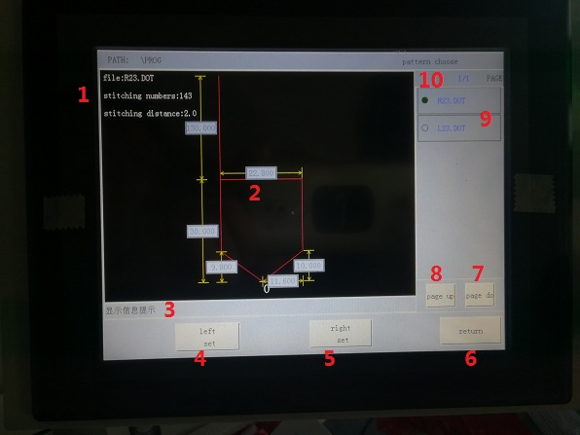

|  |  |  |
| --- | --- | --- |
|  | BUTTON | DESCRIPTION |
|  |  | File name and needle distance |
|  |  | Placket measurement |
|  | information | Current running information |
|  | Left placket | Choose current left placket pattern and save |
|  | Right placket | Choose current Right placket pattern and save |
|  | return | Return to home page |
|  | Page down | Page down to next file list |
|  | Page up | Page up to previous file list |
|  |  | File list |
|  |  | Page of file list |

**6. 图案校准界面**

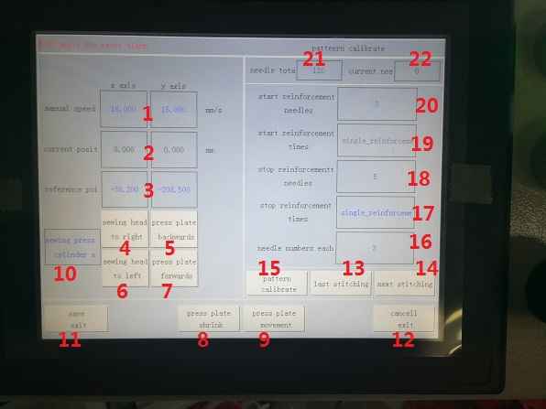

|  |  |  |
| --- | --- | --- |
|  | button | description |
|  | Manual speed | Set the sewing head ,press plate manual move speed |
|  | Current position | Current position of x axis，y axis |
|  | Reference point | The position of reference point of Current patent |
|  | Sewing head to right | Manual move sewing head to right |
|  | Press plate backwards | Manual move press plate backwards |
|  | Sewing head to left | Manual move sewing head to left |
|  | Press plate forwards | Manual move press plate forwards |
|  | Press plate shrink | Manual shrink the pressplate |
|  | Press plate movement | Manual shrink or expand the press plate |
|  | Sewing press plate cylinder movement | Sewing press plate cylinder shrink or expand |
|  | Save exit | Save change and return home pate |
|  | Cancel and exit | Cancel change and return home pate |
|  | last stitching | Manual move X, Y to last stitching |
|  | Next stitching | Manual move X, Y to next stitching |
|  | Pattern calibrate | After change the reference point,“pattern calibrate” update current pattern and move to current needle position |
|  | Needle number each | Stitching numbers each step |
|  | Stop reinforcement times | reinforcement times in the ending |
|  | Stop reinforcement needles | reinforcement needles in the ending |
|  | Start reinforcement times | reinforcement times in the beginning |
|  | Start reinforcement needles | reinforcement needles in the beginning |
|  | Total needles | Total needles of current pattern |
|  | Current needle | Current needle |

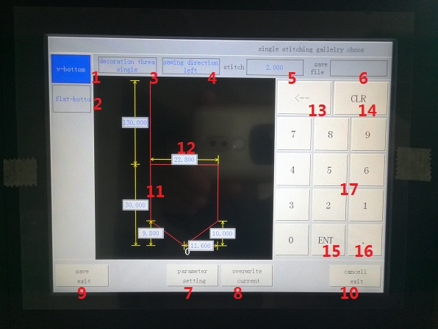

**7. 图库界面**

|  |  |  |
| --- | --- | --- |
|  | button | description |
|  | V Shape bottom | V shape bottom |
|  | Flat bottom | Flat bottom |
|  | Decoration thread | Decoration thread type: single, double, cross |
|  | Processing direction | Left or right placket |
|  | Stitching distance | Stitching distance setting |
|  | Save file as | Save file name as |
|  | Parameter setting | Create the pattern according to setting parameter |
|  | Overwrite current | Overwrite current processing file |
|  | Save exit | Save change and return |
|  | Cancel exit | Cancel changes and return |
|  |  | Pattern display |
|  |  | Measurement imput |
|  | “🡨” | delete |
|  | “CLR” | Clear off the data |
|  | “ENT” | Confirm and enter |
|  | “.” | Decimal point |
|  |  | 0~~9 |

**8. 手动测试界面**

（1）motor manual test：

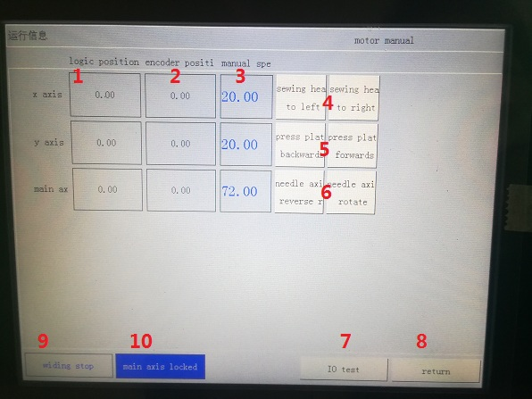

|  |  |  |
| --- | --- | --- |
|  | button | description |
|  | Logic position | Logic position X，Y , main axis |
|  | Encoder position | Encoder of X，Y, main axis |
|  | Manual speed | Manual speed of X，Y, main axis |
|  |  | manual movement of X (sewing head) |
|  |  | manual movement of Y (Press plate) |
|  |  | manual rotary of A axis(main axis)forward/reverse |
|  | IO Test | Manual test of IO |
|  | return | return |
|  | Wilding start/stop | Wilding start/stop |
|  | Main axis lock | Maix axis/locler or unlock |

（2）IO Manual test：

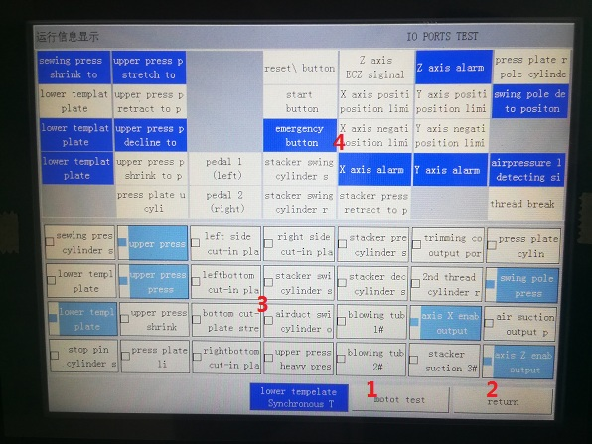

|  |  |  |
| --- | --- | --- |
|  | button | descpritio |
|  | Motor test | Manual test motor |
|  | return | return |
|  |  | Manual output |
|  |  | Manual input |

**9. 辅助功能界面**

辅助功能主要包括用户非常用功能，如：用户参数，程序更新， usb连接， 系统信息，文件管理。

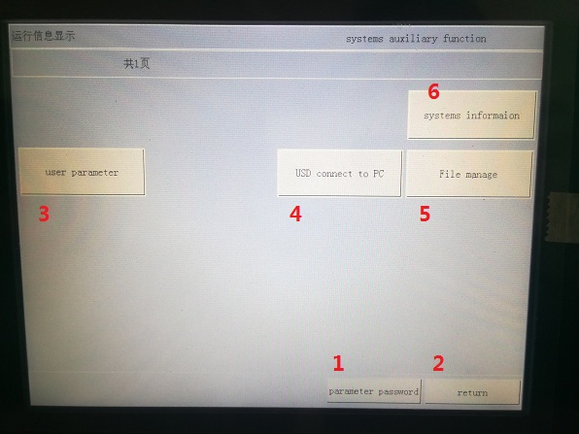

|  |  |  |
| --- | --- | --- |
|  | button | descpriton |
|  | Parameter password | Imput the password to protect the parameter |
|  | return | return |
|  | User parameter | User parameter |
|  | USB to PC | USB connect to PC |
|  | File manger | File manager |
|  | Systems information | Systems information |

**三、操　　　　　作**



**TO avoid the mistakes and hurt, please ensure below**

1、please clean the machine and add lubrication oil。

2、 AC 200V~240V。

3、please don’t use the machine if voltage is not correct

4、copmress air pressure0.5MPa

5、don’t directly look at laser

**1. 操作和运转**

**（1）sewing head operation**

* Switch on power
* Reset the sewing head
* Create patter file or choose the file from gallery
* Calibrate the pattern and save changes
* Enter into sewing interface
* Put material and step the right pedal to run
* The parameter for sewing head and service as indicated by the manual DDL-9000B

**2. 运行系统功能与设置**

**（1）图案文件创建及修改流程：**

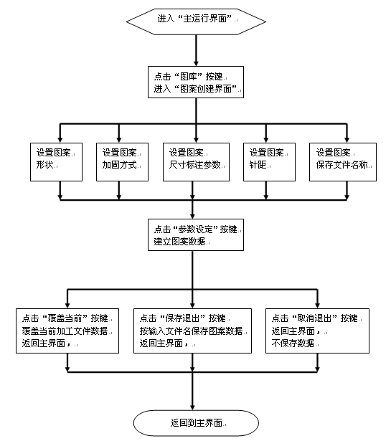

**（2）图案文件校准流程：**

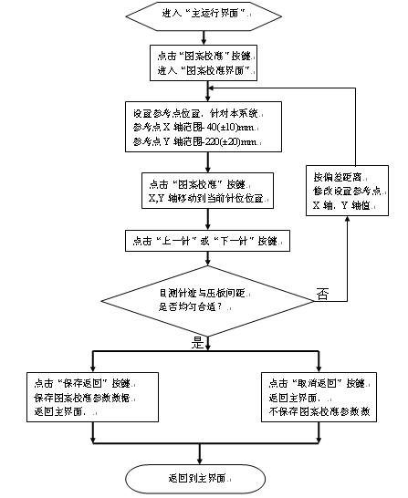

**（3）图案文件更换流程：**

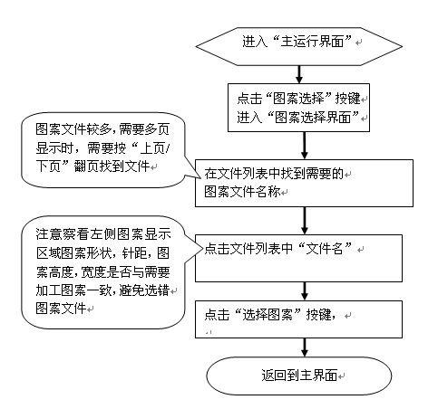

**四、故障信息一览表**

Below list is only for some main error information. If some error information out of the list come out, please kindly contact the manufacturer

|  |  |  |  |
| --- | --- | --- | --- |
| **No.** | **Error code** | **Description** | **Solution** |
| 1 | E382 | Emergency alarm | （1）check the emergency button； |
| 2 | E383 | apply for reset alarm | （1）press reset |
| 3 | E336 | Bobbin counting alarm | Set reasonable bobbin capacity. if remaining bobbin capacity is less than production demand, it will alarm to replace bobbin；  If setting capacity at 0,it will not count . |
| 4 | E388 | lower shaping plate stretch detecting error | （1）the sensor to detect the cylinder move out NOT ON or always ON ；  （2）cylinder failure to move out  （3）check the cylinder move out solenoid and cylinder  （4）check the air source。  （5）check the IN18 imput port |
| 5 | E389 | lower shaping plate retract detecting error | 1）the sensor to detect the cylinder move out NOT ON or always ON ；  （2）cylinder failure to move out  （3）check the cylinder move out solenoid and cylinder  （4）check the air source。  （5）check the IN19 input port。 |
| 6 | E391 | lower shaping plate decline detecting error | 1）the sensor to detect the cylinder move out NOT ON or always ON ；  （2）cylinder failure to move out  （3）check the cylinder move out solenoid and cylinder  （4）check the air source。  （5）check the IN20 input port。 |
| 7 | E412 | thread break alarm | 1. Threading again 2. Check I10 input port |
| 8 | E393 | swing pole decline detecting error | 1）the sensor to detect the cylinder move out NOT ON or always ON ；  （2）cylinder failure to move out  （3）check the cylinder move out solenoid and cylinder  （4）check the air source。  （5）check the IN21 input port |
| 9 | E465  E466  E468 | X servo motor alarm  Y servo motor alarm  Z servo motor alarm | Power off and reset。  （1）check the servo driver |
| 10 | E447  E448  E450 | X position limit alarm  Y position limit alarm  Z position limit alarm | reset  （1）X/Y/Z positive/negative limit positon sensor NOT ON or always on |
| 11 | E394 | pressing plate rising cylinder stretch detecting error | （1）the sensor to detect the cylinder move out NOT ON or always ON ；  （2）cylinder failure to move out  （3）check the cylinder move out solenoid and cylinder  （4）check the air source。  （5）check the IN22 input port |
| 12 | E396 | upper pressing plate stretch detecting error | （1）the sensor to detect the cylinder move out NOT ON or always ON ；  （2）cylinder failure to move out  （3）check the cylinder move out solenoid and cylinder  （4）check the air source。  （5）check the IN25 input port |
| 13 | E397 | upper pressing plate retract detecting error | （1）the sensor to detect the cylinder move out NOT ON or always ON ；  （2）cylinder failure to move out  （3）check the cylinder move out solenoid and cylinder  （4）check the air source。  （5）check the IN26 input port |
| 14 | E399 | upper pressing plate decline detecting error | （（1）the sensor to detect the cylinder move out NOT ON or always ON ；  （2）cylinder failure to move out  （3）check the cylinder move out solenoid and cylinder  （4）check the air source。  （5）check the IN27 input port |
| 15 | E411 | Air pressure alarm | （1）check the air pressure 0.4mpa；  （2）check the IN9 input port。 |
| 16 | E407 | sewing press plate retract detecting error | （1）the sensor to detect the cylinder move out NOT ON or always ON ；  （2）cylinder failure to move out  （3）check the cylinder move out solenoid and cylinder  （4）check the air source。  （5）check the IN71 input port |
| 17 | E401 | upper pressing plate retract detecting error | （1）the sensor to detect the cylinder move out NOT ON or always ON ；  （2）cylinder failure to move out  （3）check the cylinder move out solenoid and cylinder  （4）check the air source。  （5）check the IN28 input port |
| 18 | E402 | pressing plate upper position limit cylinder stretch detecting error | （1）the sensor to detect the cylinder move out NOT ON or always ON ；  （2）cylinder failure to move out  （3）check the cylinder move out solenoid and cylinder  （4）check the air source。  （5）check the IN29 input port |

**五、电气原理图**

**1. 输入信号接线**

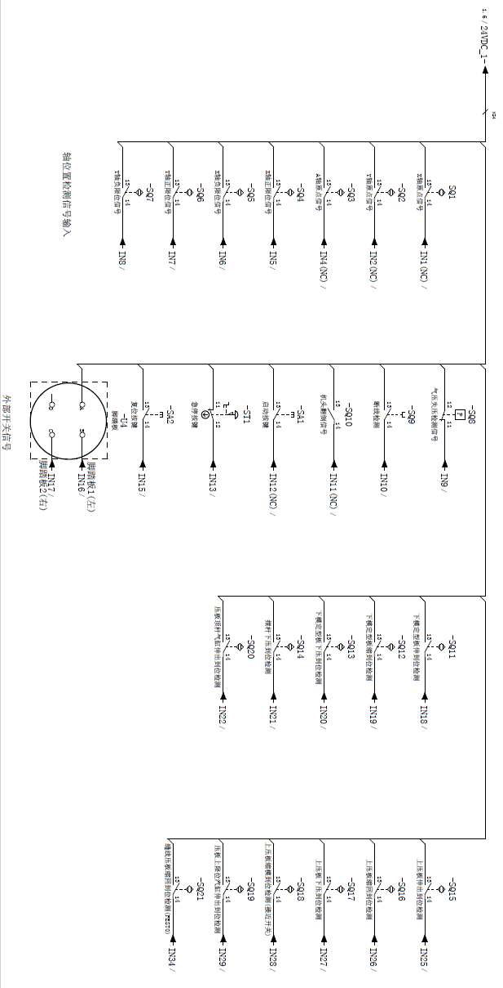

**2. 输出信号接线**

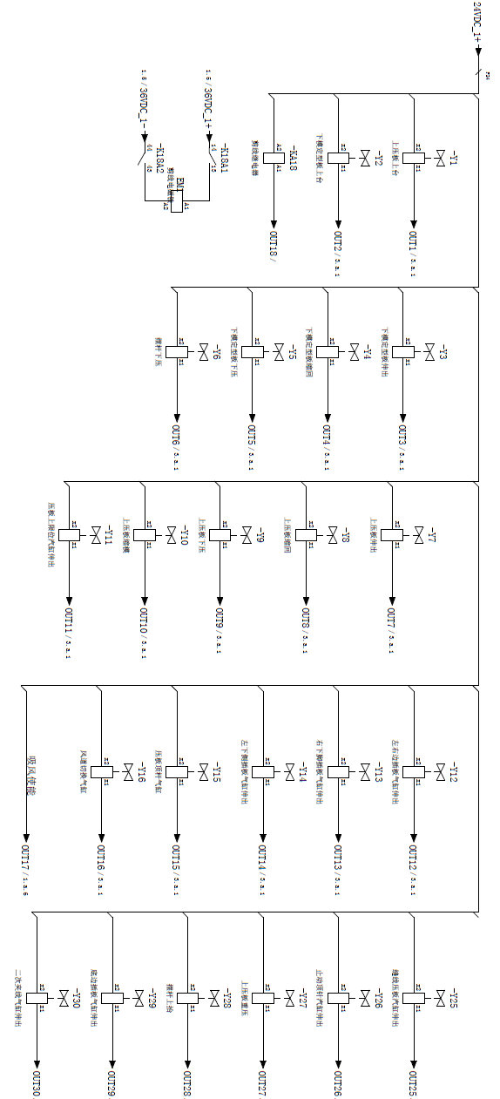

**3. 电磁阀接线**

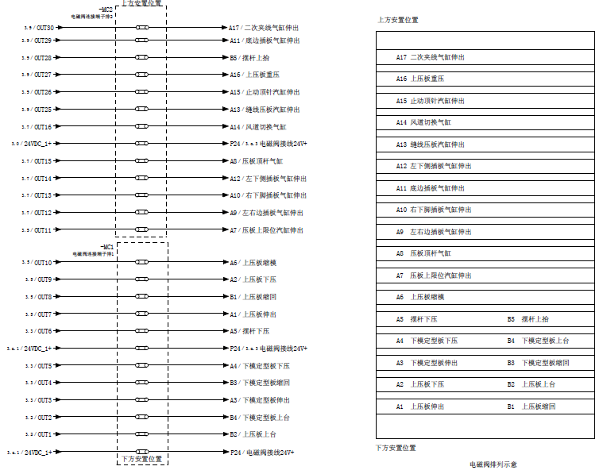





**※规格及外观经过改良可能会与图片所示有所不同**

**邮编： 201616**

**电话：64953003，67665788**

**传真：64957015，57874743**

**Http:// www.shweishi.com**

**上海威士机械有限公司**

**上海市松江区文吉路339号**